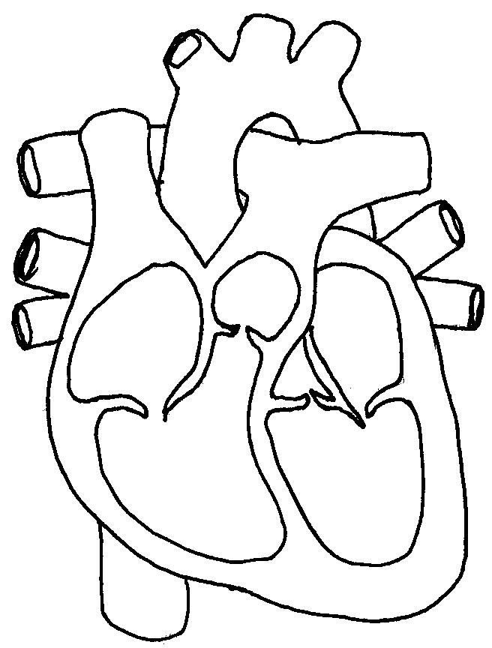Name_____________________________